Kickstart Data Analysis

Based on the data provided, three things that can be determined from the graphical representations are as follows:

1. By overall category, theater kickstart projects have the greatest number of successful projects. This can be due to the askew of total count of projects that are in kickstarter that are classified as the theater category. Another observation from this data is that the music category has the highest percentage of successful projects.

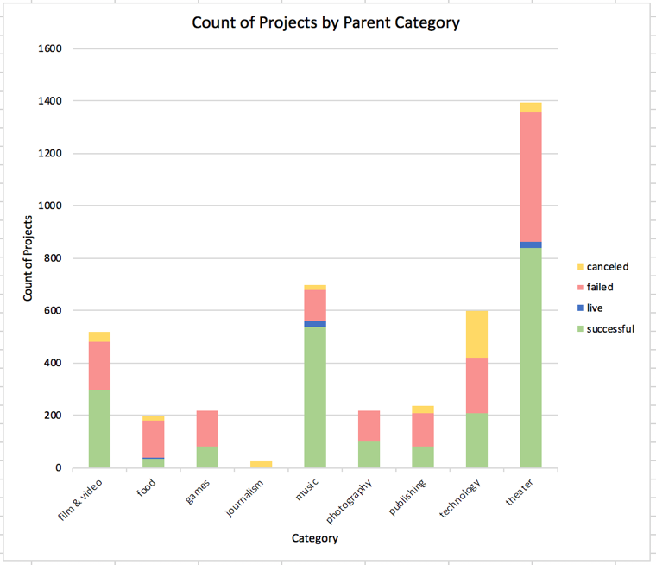

1. By Sub-category, we can break the information down further and see that the majority of kickstarter projects are plays. Among the plays, more than 50% are completed. Another observation that can be made from this subset of data, is that the next highest sub-category, Rock (Music), has nearly a 100% success rate.

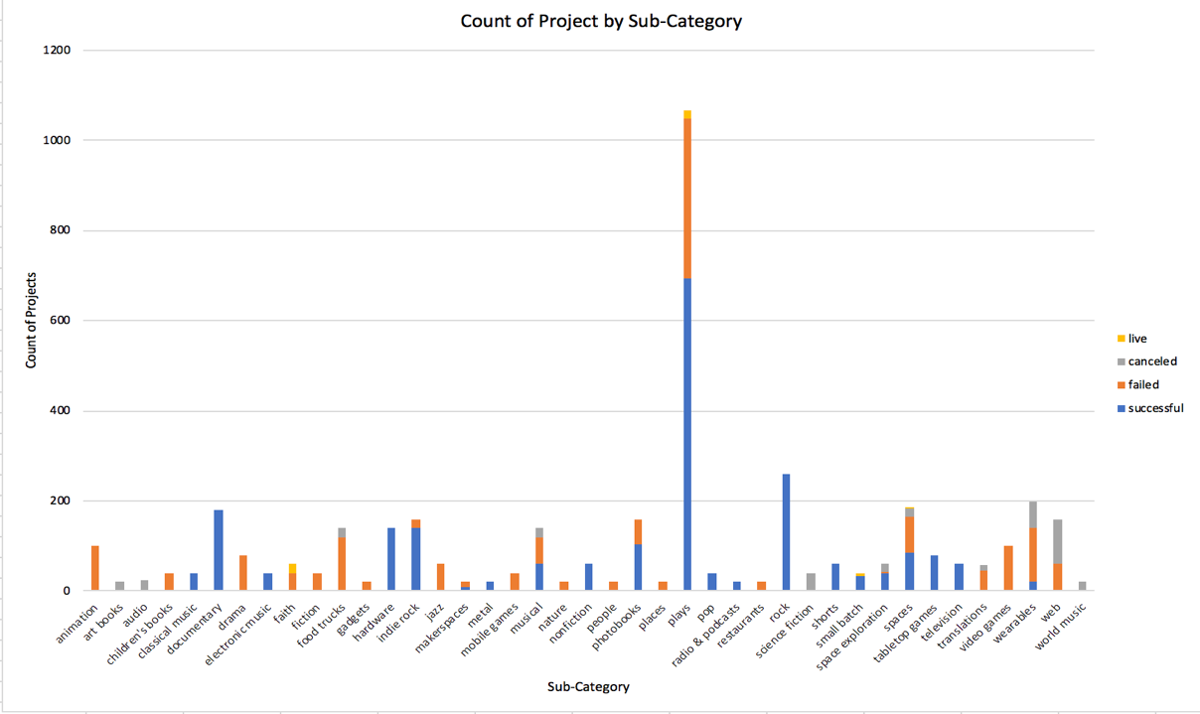

1. When analyzing the project states throughout the years by month, it seems to show that kickstart projects are mostly successful between the months of April and June. This could be due to funding availability increasing from tax returns near that time and excess income can lead to donations and free up financial resources needed to complete the projects. Another observation that can be made is that the rate of cancellations month over month, tends to stay the same. There is no significant increase or decrease by month.

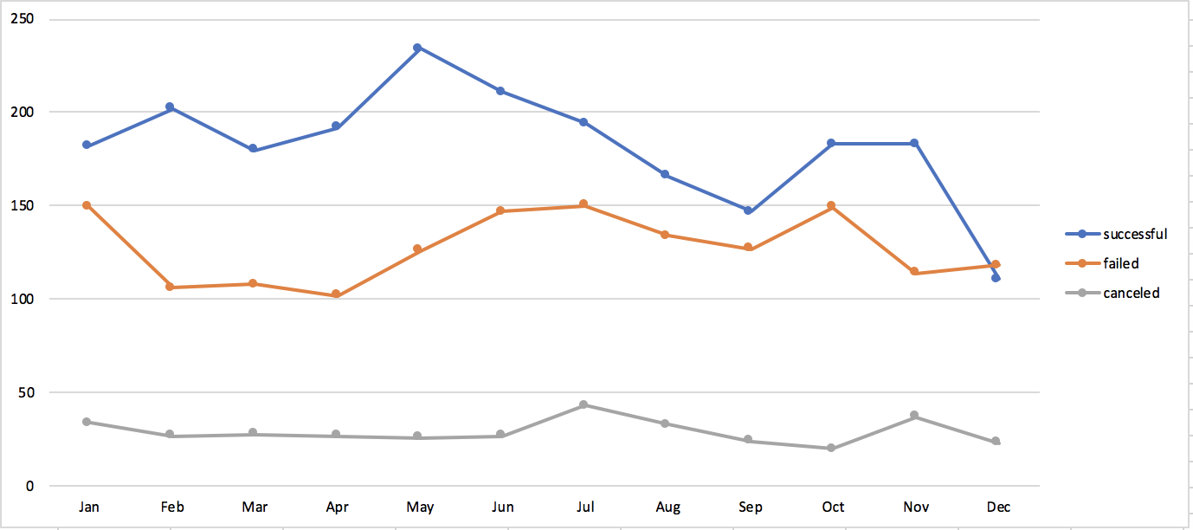

The limitations of this data include the personnel coutn and resources used to complete these projects, which leaves the inability to correlate the project team size against the time to completion, and goal of funds. Another limitation is this data set only contains data the success of the kickstart project and not its success past the kickstart phase (market presence, attendance, number of shows, etc). Without this data, we are unable to show trends of the category/sub-categories being successful and staying successful beyond funding.

Some other ways of representing the data is showing the count of backers against the categories/sub-categories. This would be able to show trends of what backers are more interested in helping fund by projects. To go a step further, we can show a trend by showing this data across years to begin forecasting potential campaigns to follow. This could be graphically represented using a line chart using the month/year as the x-axis, and the backer count as the y-axis. Another data analysis we can run is the average time that projects are completed, and funding percentage over time. This will allow us to model the categories and compare a project’s success against others in its categories/subcategories.